HANS RAJ MAHILA MAHA VIDYALYA, JALANDHAR

Handbook for Human Values and Professional Ethics


This hand book is in acquiescence with SCHEME FOR “HUMAN RIGHTS AND VALUES IN EDUCATION” underlined in the Xth plan of UGC. The need of human values, professional ethics, goals and methods to attain them is derived from UGC hand book on “Inculcation of Human Values and Professional Ethics in HEIs”(Mulyapravah, UGC, New Delhi).

Our aim Our institution aims to develop the much needed set of human values and beliefs in all the stakeholders that enables them to become empathetic global citizens, who can definitely make a positive contribution to this universe. Our purpose is to cultivate and nourish human values amongst individuals so that they as responsible citizens take responsibility for themselves, family, society and for the environment around.

Objectives

- To create awareness, conviction & commitment to values for improving the quality of life through education, and for advancing social and human well being.
- To reinstate the rich cultural legacy and human values of which we are the custodians.
- To focus on professional ethics which are broader indicators of desirable actions vis- à-vis undesirable actions.
- To lay down broader guidelines of values and ethics for internal and external stakeholders.

Human Values

We firmly believe that the outcome of education is to facilitate actualization of human potential by making its stakeholders, particularly higher educational administrators, teachers and learners conscious about human values and professional ethics. The principal values to be actualized are as follows:
- Compassion and Love (Prem and Karunaa): Love and Compassion is the sincere care for others, kindness and empathy. The concept of ‘Love for all’ leads to consideration of the whole world as a family as in the concept of 'Vasudhaiva Kutumbakam'.
- Peace (Shanti): The scope of peace includes peace at the individual level and at the world level. For world peace, peace at the level of individual, society and nations is imperative.

- Truth (Satya): Truth is eternal and unchanging, as it deals with ultimate and unchanging reality. In professional life, the simplest manifestation of truth is in sincerity that can be seen in terms of commitment to work.
- Non-Violence (Ahimsa): Non-violence is a result of restraint from consciously doing any harm through one’s thoughts, speech or action to any entity, living or nonliving. Non-violence demands abstinence from hatred and nurturing love and compassion for all beings.
- Righteousness (Dharma): Righteousness is the backbone of core human values and also of human existence. It involves practicing good manners and decorum at every stage. In simple language, it is marked by ‘right conduct’.
- Renunciation or Sacrifice (Tyaaga): Renunciation begins when selfishness ends. Renunciation in its simplest form is seen in austerity, sense control, and selflessness.
- Service (Sevaa): When love and compassion for others and willingness to sacrifice for others out of love take the form of action, it becomes service. Service is possible only when one loves others as one’s own, not as other. The value of service demands equanimity without any conditions or discrimination on the lines of caste, creed, race, region or religion.

Professional Ethics

Human values and professional ethics are intertwined. Ethics are standards of conduct that indicate how one should behave based on moral duties and virtues arising from principles about right and wrong.

The best practices of Professional Ethics in our organization include:

- Complete transparency in hiring and training of employees
- Equal opportunity for all without taking into consideration caste, creed, religion, language or any other bias
- Student Diversity and Inclusivity
- Decisions taken in larger public interest
- Inculcating in the employees the basic tools of ethical decision making

- Regular Vedic/Ethics Enhancement Programmes for students, teaching and non- teaching staff

Values and Ethics for Stakeholders
The realization and accomplishment of an Institution’s Mission and vision is determined by value-based ethical conduct of its dedicated management, faculty members, non-teaching staff and students. All the stakeholders of our institution are guided by the following core values:
  - Justice and Harmony
  - Trust and Respect
  - Honesty
  - Truthfulness
  - Integrity and Commitment
  - Excellence
  - Diversity and Inclusivity
  - Sustainability and Accountability
  - Student Support
  - Ethics and Dignity
  - Growing by Learning
  - Open Mindedness
  - Leading through Innovation
  - Collaboration and Public Engagement

Professional Ethics for Stakeholders The Principal would
- see that the provisions of Acts/Statutes/Ordinances and Regulations of the college are duly observed and business of the instituion is carried out in strict adherence thereto.
- comply with laws, rules, and regulations of the government applicable to the instituion.
- provide inspirational and motivational value-based academic and executive leadership through policy formation, operational management, optimization of human resources and concern for environment and sustainability.

The Non-teaching staff would
- carry out official decisions and policies faithfully and impartially, seeking to attain the highest possible standards of performances.
- encourage the staff to maximise their efficiency.
- create conditions that inspire teamwork.
- act timely to redress the genuine grievances.
- maintain the confidentiality of the records and other sensitive matters.
- care for the institute’s property.
- refrain from any form of discrimination.
- not accept bribes or indulge in any corrupt practices.
- make every effort to complete the assigned work in a time-bound manner.

The Teachers would

- act as a role model for students by displaying good conduct, set a standard of dress, speech and behavior worthy of example to the students.
- act as friend, philosopher and guide of students.
- help students in identifying their potential and support through counseling and mentoring.
- create a conducive environment for teaching–learning process and strive for innovative practices and knowledge creation.
- observe punctuality in teaching and other duties.
- exhibit decent behaviour with all.
- refrain from harassment of student in any form.
- actively participate in institutional development.
- refrain from any type of discrimination
- inculcate human values, scientific outlook and concern for the environment among students and others.
- develop an understanding of our heritage and encourage students to actively participate in scheme/ activities of national priorities.

- actively work for national integration and communal harmony and be sensitive to societal needs and development.
- abide by Act, Statutes, Ordinances, rules, policies, procedures of the institution and respect its ideals, vision, mission, cultural practices and the traditions.

The staff union would

- support the administration for developmental activities.
- raise the issues in a dignified manner.

Students would

- abide by Act, Statutes, Ordinances, rules, policies, procedures of the institution and respect its ideals, vision, mission, cultural practices and the traditions.
- remain punctual, disciplined and regular in attending classes.
- observe modesty in their overall appearance and behaviour and behave with dignity and courtesy with teachers, staff and fellow students.
- act as a role model for the junior students by attaining the highest level of values and morality.
- maintain harmony among students belonging to different socio-economic status, community, caste, religion or region.
- contribute towards cleanliness of the campus and surroundings and care for the institutional properties.
- observe proper behavior while on educational tour/visit or excursion.
- maintain the highest standards of academic integrity and strive to keep campus ragging free.
- be sensitive to gender issues and to societal needs and development.
- maintain good health and refrain from any kind of intoxicants.

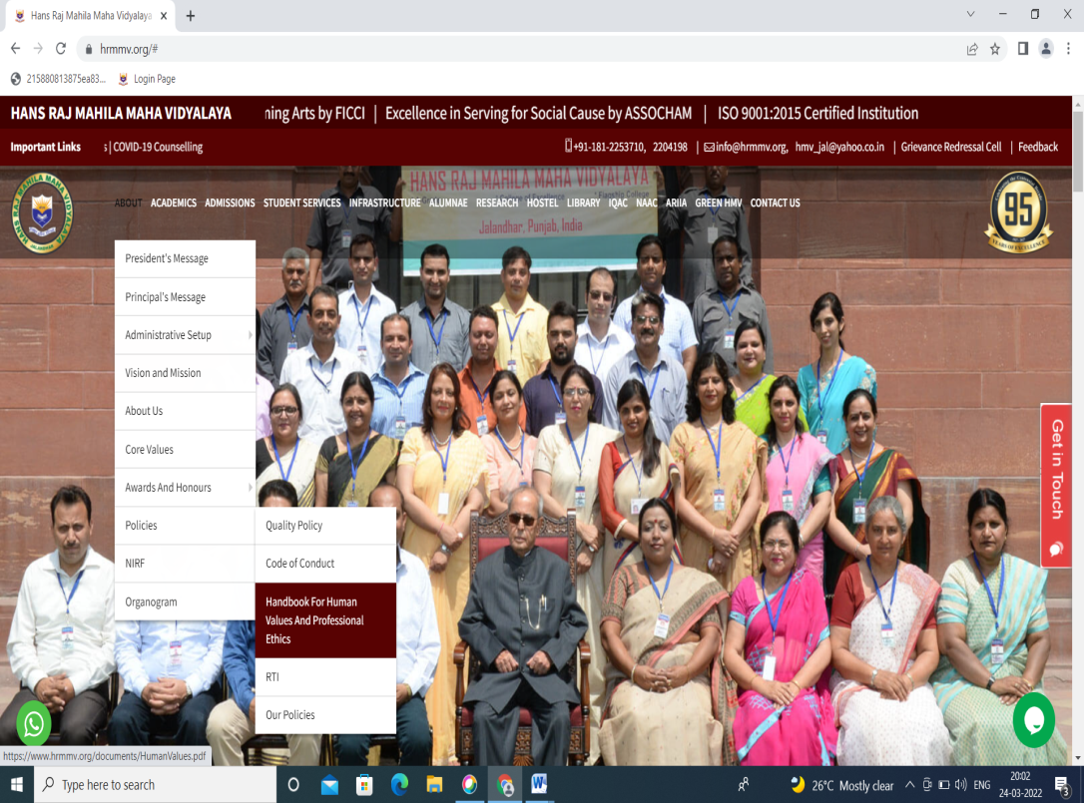



https://www.hrmmv.org/documents/HumanValues.pdf

